Task 9: Selenium Test Design and Local Execution
Command 1 — Find controllers and security configuration
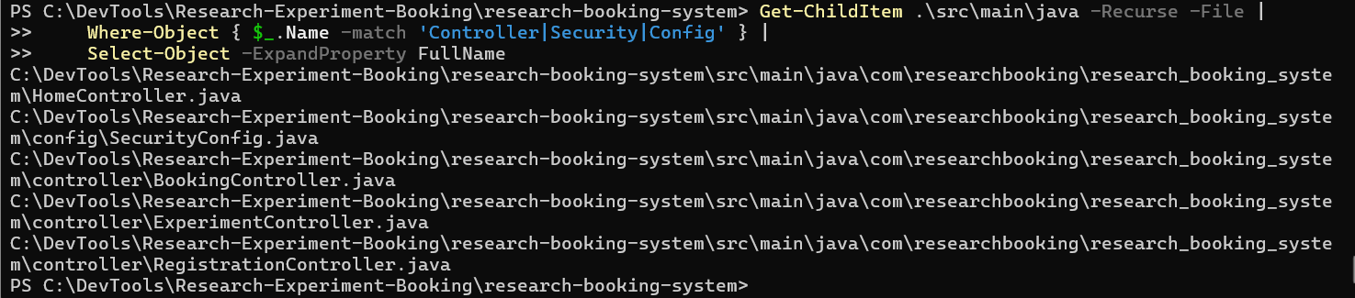
Create the browser interface controller
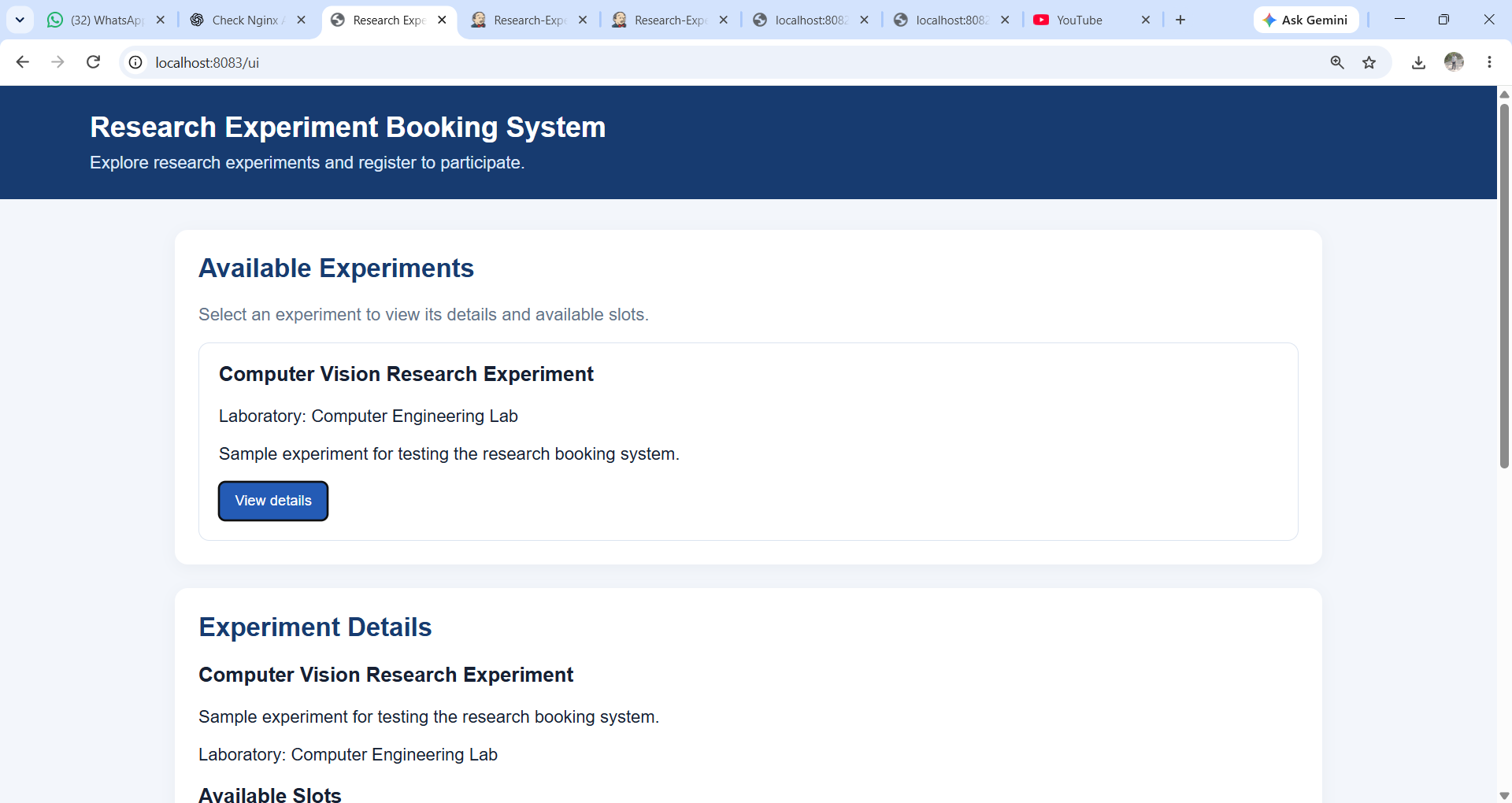

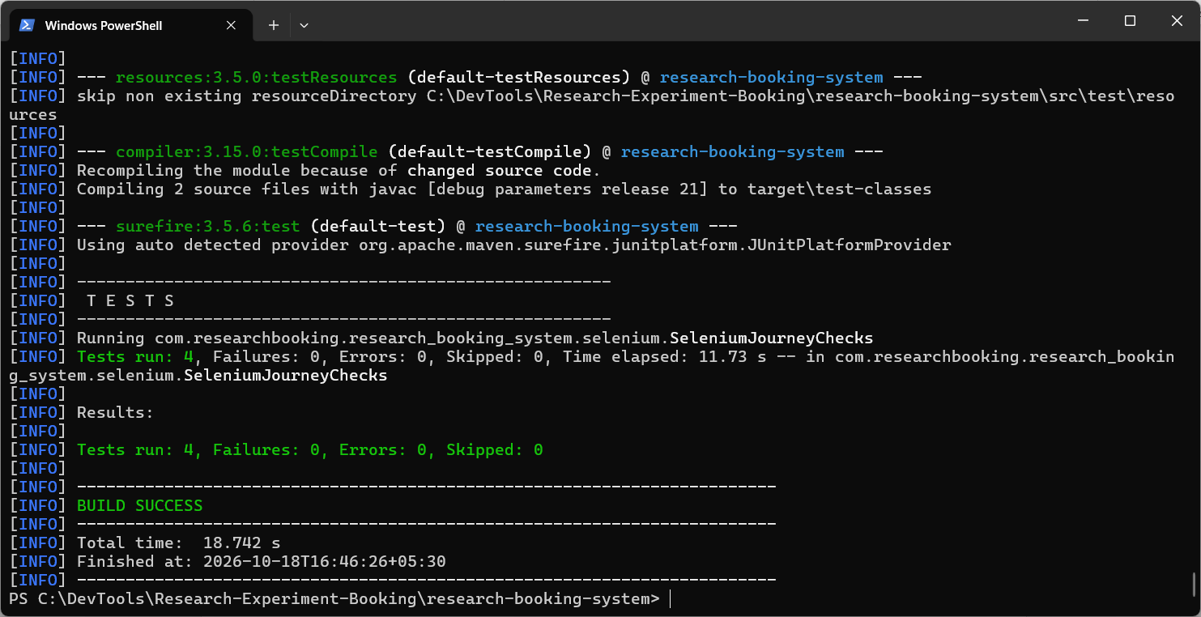
Verify your Task 9 deliverables
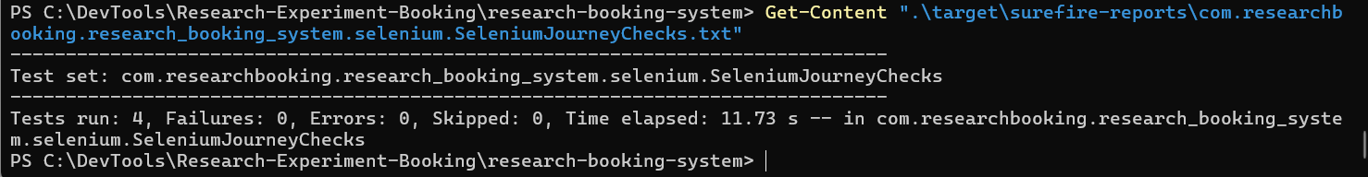
Task 9: Selenium Test Design and Local Execution
Below is a complete, submission-ready explanation for your Research Experiment Booking System. You can use this content in your practical journal, project report, or Task 9 documentation.
1. Objective and Test Environment
1.1 Objective
The objective of Task 9 is to test the important user journeys of the Research Experiment Booking System using Selenium WebDriver and verify that the application works as expected.
Selenium automates browser actions such as opening a webpage, clicking buttons, filling forms, and checking displayed information. Assertions are used to compare the actual application behaviour with the expected results.
The main objectives are:
- Verify that the experiment dashboard displays available experiments.
- Verify that experiment details and available time slots load correctly.
- Check that the student registration form validates required fields.
- Verify that a student can register successfully using valid details.
- Capture screenshots when a test fails and generate a test execution report using Maven.
1.2 Test Environment
Component | Details
Operating system | Windows
Programming language | Java
Application framework | Spring Boot
Testing framework | JUnit 5
Browser automation | Selenium WebDriver 4.51.0
Build and test tool | Apache Maven
Browser | Google Chrome, headless mode
Application URL | http://localhost:8083/ui
Experiments API | http://localhost:8083/api/experiments
Test class | SeleniumJourneyChecks.java
Report location | target/surefire-reports/
Failure screenshot folder | target/selenium-screenshots/
Note: Headless mode runs Chrome without opening a visible browser window. Selenium Manager helps Selenium obtain and manage the required browser driver.
The tests are executed locally against the running Spring Boot application. The application must be available at port 8083 before running the suite.
2. Four Test Cases with Test Data and Results
The Selenium test suite contains four critical test cases. The latest execution completed with 4 passed, 0 failed, and 0 errors.
Test Case 1: Verify the Experiment Dashboard
Test method: dashboardShouldDisplayExperiments
Item | Description
Test case ID | TC-01
Objective | Verify that the dashboard displays the experiment information.
Test data | Application URL: http://localhost:8083/ui; sample experiment: Computer Vision Research Experiment.
Steps | 1. Open the application. 2. Wait for the dashboard to load. 3. Check that the experiment section and experiment cards are displayed.
Expected result | The dashboard loads successfully and displays experiment information.
Actual result | The dashboard test passed successfully.
Status | PASS
Test Case 2: Verify Experiment Details and Time Slots
Test method: experimentDetailsAndSlotsShouldLoad
Item | Description
Test case ID | TC-02
Objective | Verify that experiment details and available time slots can be loaded.
Test data | Experiment ID: 1 (sample experiment).
Steps | 1. Open the dashboard. 2. Select an experiment using the “View details” button. 3. Verify that the details section loads. 4. Check the slots section.
Expected result | The selected experiment's details are displayed, and the slots section loads without an application error.
Actual result | The experiment details and slots test passed successfully.
Status | PASS
Test Case 3: Verify Registration Form Validation
Test method: registrationFormShouldValidateRequiredFields
Item | Description
Test case ID | TC-03
Objective | Verify that the registration form checks required fields.
Test data | Full name: blank; email: blank; password: blank.
Steps | 1. Open the registration form. 2. Leave the required fields empty. 3. Attempt to submit the form. 4. Verify the required-field validation.
Expected result | The form should prevent submission when required fields are missing and indicate that the required information must be entered.
Actual result | The registration validation test passed successfully.
Status | PASS
Test Case 4: Verify Successful Student Registration
Test method: studentShouldRegisterSuccessfully
Item | Description
Test case ID | TC-04
Objective | Verify that a student can register with valid information.
Test data | Full name: a sample student name; email: a unique test email; password: a valid test password.
Steps | 1. Open the registration form. 2. Enter a valid name, email and password. 3. Submit the form. 4. Verify the registration response.
Expected result | The application accepts the valid registration and displays a success response.
Actual result | The student registration test passed successfully.
Status | PASS
Important: Use a unique email address for each new registration test run if the application prevents duplicate registrations. The test data above describes the scenario; use the exact values in your Java script if your examiner requires reproducible test data.
3. Steps to Execute the Selenium Suite Using Maven
Follow these steps on your Windows computer.
Step 1: Open the project folder
Open PowerShell and execute:
cd C:\DevTools\Research-Experiment-Booking\research-booking-system
Step 2: Ensure the application is running
Open the application in your browser:
http://localhost:8083/ui
If the page loads correctly, continue to the next step.
Step 3: Execute the Selenium tests
Run:
mvn "-Dtest=SeleniumJourneyChecks" test
Maven compiles the test code, starts the Selenium test suite, executes the four test cases, and generates the test report.
Step 4: Verify the execution result
Look for the following output:
Tests run: 4, Failures: 0, Errors: 0, Skipped: 0

BUILD SUCCESS
Your latest run produced this result, with a total Maven build time of 10.912 seconds.
Step 5: Open the test report
Execute:
Get-Content ".\target\surefire-reports\com.researchbooking.research_booking_system.selenium.SeleniumJourneyChecks.txt"
The report should contain a summary similar to:
Test set: com.researchbooking.research_booking_system.selenium.SeleniumJourneyChecks

Tests run: 4, Failures: 0, Errors: 0, Skipped: 0
4. Failure Screenshot Mechanism and Report Location
4.1 Failure screenshot mechanism
The Selenium test class includes an @AfterEach cleanup method. When a test failure is recorded by the test's failure-tracking mechanism, the code captures a screenshot of the browser using Selenium's TakesScreenshot functionality.
The screenshot is saved with the test name and a timestamp to help identify which test failed.
The process is:
Execute Selenium test
Check test result
Test passes
Continue and finish the test.
Test fails
Capture and save the browser screenshot.
4.2 Locations of test evidence
Evidence | Location
Selenium test script | src\test\java\com\researchbooking\research_booking_system\selenium\SeleniumJourneyChecks.java
Surefire text report | target\surefire-reports\com.researchbooking.research_booking_system.selenium.SeleniumJourneyChecks.txt
Surefire XML report | target\surefire-reports\TEST-com.researchbooking.research_booking_system.selenium.SeleniumJourneyChecks.xml
Failure screenshots | target\selenium-screenshots\
To check the screenshot folder, run:
Get-ChildItem ".\target\selenium-screenshots" -ErrorAction SilentlyContinue
If all tests pass, the screenshot folder may not exist because the code only saves screenshots when a failure is captured. This is normal.
Why screenshots are useful: They provide visual evidence of the browser state at the time of a failure, making it easier to investigate problems and include evidence in a test report.
5. Final Execution Summary
The Selenium WebDriver test suite was executed locally through Maven against the Research Experiment Booking System.
Final test execution report
Total test cases
4
Passed
4
Failed
0
Errors
0
Skipped
0
Total Maven build time
10.912 sec
Overall result: BUILD SUCCESS
Conclusion
Task 9 was completed successfully. Four Selenium WebDriver test cases were designed and executed to verify the experiment dashboard, experiment details and slots, registration form validation, and successful student registration. Maven generated the test execution report, and the test class includes a mechanism for capturing screenshots when failures are detected.
The results indicate that all four tested user journeys passed in the latest execution. This confirms the tested functionality worked as expected under the local test conditions; it does not guarantee that every feature of the application is defect-free.
Submission checklist
- Include SeleniumJourneyChecks.java.
- Include the Surefire text report and, if required, the XML report.
- Include screenshots if any failures were captured.
- Include this test plan in your practical journal or project documentation.
One final suggestion: would you like a reminder to rerun the Selenium tests and collect the evidence before your project submission?

